## horizontal line



Statistical analysis for salaries program

30.04.2019

Ayaalla Mohamed Eltabey Section (5)  
Ebtihal Sherif Youssef Section (1)  
Gehad Wael farouk Section (6)  
Salma Naguib Section (8)  
Sameha mohamed Hatem Section (8)

# Overview

It is a system that takes a csv file contain salaries & worked hours of employees and make some statistical operation on the salary & worked thier hours.

# Goals

1. Calculate Descriptive Statistic.
2. Calculate Correlation / Regression .

# Specifications

Descriptive Statistic : -

* The Sum of Salaries.
* The Maximum Salary & The Minimum Salary.
* The Mean of Salaries.
* The Median.
* Standard Deviation.
* The Variance.

# How to Use Our System

## Import the Excel Sheet from your PC :

## 

## Example of what the data should be like

1. hint( you can enter any CSV file that contains Hours And Salary Columns )

## 

## Choose your Option :

1. Descriptive analysis for one dataset column “salary”
2. Correlation and regressions for two dataset columns “Hours & salary”

## 

## The System gives you the Results & bar Chart graph & Line graph ( if the user choose cal. descriptive statistics ) :

## The System gives the user the correlation value & Correlation type& Scatter Plot with regression line ( if the user choose cal. Correlation ) :

# Some Parts of Code :

* Imported Packages (using Python 3.7 ): 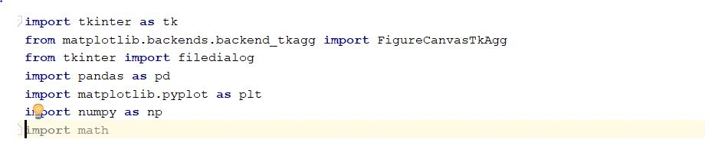
* Calculate Descriptive Statistic function: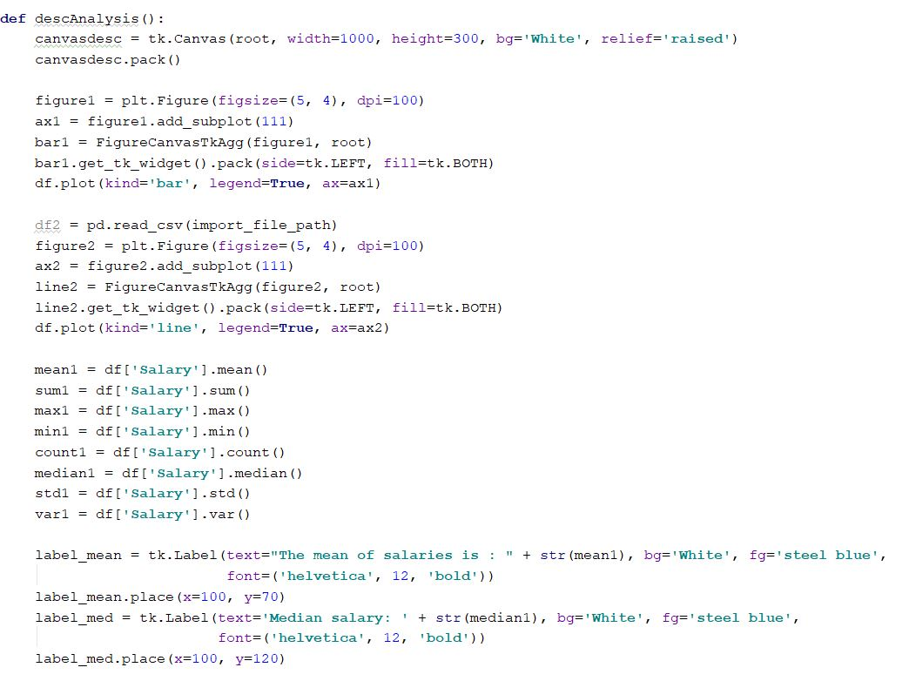
* Reading the file :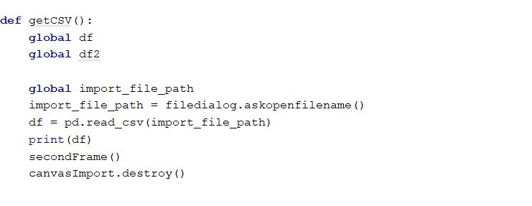
* Calculation The Correlation and regression function: 